Assignment 1

1. What is SDLC.

ANS:- SDLC is structure imposed on the development of a software product that define the process for planning , implementation ,tesating,documentation,deployement,and ongoing maintenance and support.

1. What is software testing?

ANS:- Software testing is a process used to identify the correctness, completeness, and Quality of developed computer software.

1. What is agile methodology?

ANS:- Agile SDLC model is a combination of iterative and incremental process models with focus on process adaptability and customer satisfaction by rapid delivery of working software product.

1. What is SRS.

ANS:- A software requirements specification (SRS) is a complete description of the behavior of the system to be developed.

It includes a set of use cases that describe all of the interactions that the users will have with the software.

Use cases are also known as functional requirements. In addition to use cases, the SRS also contains nonfunctional (or supplementary) requirements.

1. What is OOPS.

ANS:- Identifying objects and assigning responsibilities to these objects.

Objects communicate to other objects by sending messages.

Messages are received by the methods fan object

An object is like a black box.

The internal details are hidden.

Object is derived from abstract data type.

1. Write basic concept of OOP.

ANS:-Object, Class, Encapsulation ,Inheritance, Polymorphism, Overriding, Overloading, Abstraction

1. What is Object.

ANS:- That is both data and function that operate on data are bundled as a unit called as object.

1. What is class.

ANS:-A class represents an abstraction of the object and abstracts the Properties and behavior of that object.

1. What is an encapsulation.

ANS:-Encapsulation is the practice of including in an object everything It needs hidden from other objects. The internal state is usually Not accessible by other objects.

1. What is inheritance.

ANS:- Inheritance means that one class inherits the characteristics ofanother class. This is also called a “is a” relationship.

1. What is polymorphism.

ANS:- Polymorphism means “having many forms”. It allows different objects to respond to the same message in different ways, the response specific to the type of the object.

1. Draw use case on online book shopping.

ANS:-

Customer

Book shopper

1. Draw use case on online bill payment system(paytm).

ANS:- Login

Update bank balance

Bill paying menu

USER

Fill detail

Make payment

Payment successfully

Logout

14. Write SDLC phases with basic introduction

ANS:- There are six phases of SDLC.

1 Requirements collection/gathering:- Establish customer needs.

2 Analysis:- model and specify the requirements-“What”.

3 Design-: Model and specify a solution – Why

4 Implementation:- Construct A solution in software.

5 Testing:- Validate the solution against the Requirement.

6 Maintenance:-Repair defects and adapt the solution to The new requirements.

1. Explain phases of the waterfall model.

ANS:-The sequential phases in Waterfall model are −

* **Requirement Gathering and analysis** − All possible requirements of the system to be developed are captured in this phase and documented in a requirement specification document.
* **System Design** − The requirement specifications from first phase are studied in this phase and the system design is prepared. This system design helps in specifying hardware and system requirements and helps in defining the overall system architecture.
* **Implementation** − With inputs from the system design, the system is first developed in small programs called units, which are integrated in the next phase. Each unit is developed and tested for its functionality, which is referred to as Unit Testing.
* **Integration and Testing** − All the units developed in the implementation phase are integrated into a system after testing of each unit. Post integration the entire system is tested for any faults and failures.
* **Deployment of system** − Once the functional and non-functional testing is done; the product is deployed in the customer environment or released into the market.
* **Maintenance** − There are some issues which come up in the client environment. To fix those issues, patches are released. Also to enhance the product some better versions are released. Maintenance is done to deliver these changes in the customer environment.

1. Write phases of spiral model.
2. ANS:- Planning: The first phase of the Spiral Model is the planning phase, where the scope of the project is determined and a plan is created for the next iteration of the spiral.
3. Risk Analysis: In the risk analysis phase, the risks associated with the project are identified and evaluated.
4. Engineering: In the engineering phase, the software is developed based on the requirements gathered in the previous iteration.
5. Evaluation: In the evaluation phase, the software is evaluated to determine if it meets the customer’s requirements and if it is of high quality.
6. Planning: The next iteration of the spiral begins with a new planning phase, based on the results of the evaluation.
7. The Spiral Model is often used for complex and large software development projects, as it allows for a more flexible and adaptable approach to software development. It is also well-suited to projects with significant uncertainty or high levels of risk.
8. Write agile manifesto principles.

ANS:- **The four core values of Agile software development as stated in the Agile Manifesto are as follows:**

* 1 Individuals and interactions over processes and tools.
* 2 Working software over comprehensive documentation.
* 3 Customer collaboration over contract negotiation.
* 4 Responding to change over following a project plan.

1. Explain working methodology of agile model and also write pros and cons.

ANS:- agile methodology is a project management strategy that divides the project into multiple phases, encouraging continuous improvement for each phase. In the beginning of the project, the team cycles through planning, evaluation and execution stages to collaborate toward multiple project goals. As a methodology, the agile project strategy

1. Draw use case on online shopping product using COD.

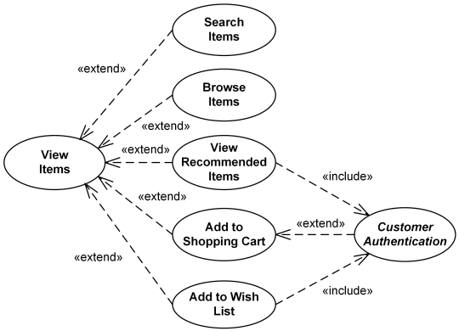

1. Draw use case on online shopping product using payment gateway.

ANS:-

